**How to Configure Microsoft Outlook Mail Client for IITK Webmail**

1. Click on “Start “and Type “Control” to open “Control Panel” Option.

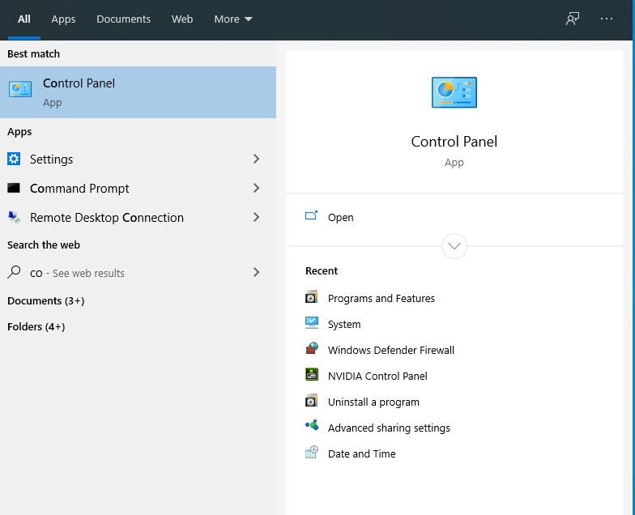

1. Click on “Mail” Option.

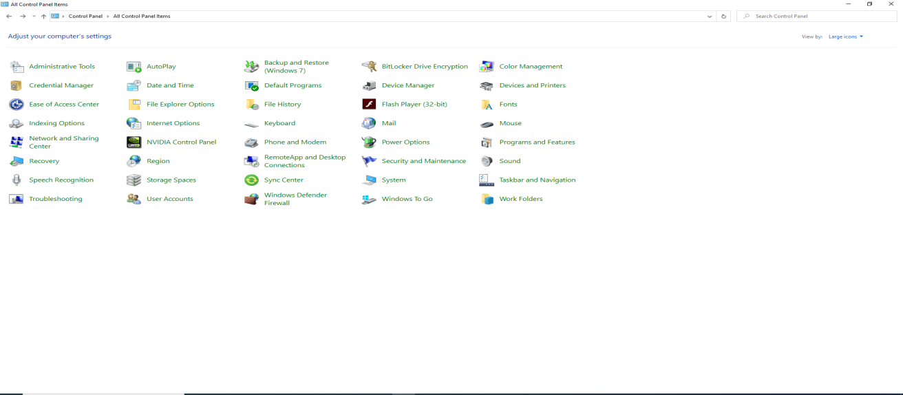

1. Click “Add” to add a profile name.

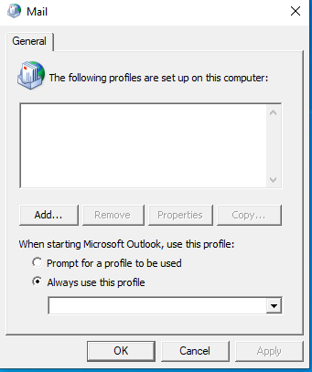

1. Enter any profile name (e.g. “IITK Webmail”).and Click on “OK” button.

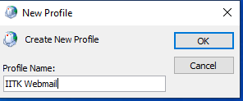

1. Select “Manually configure server setting or additional server type” option and click on “Next” button.

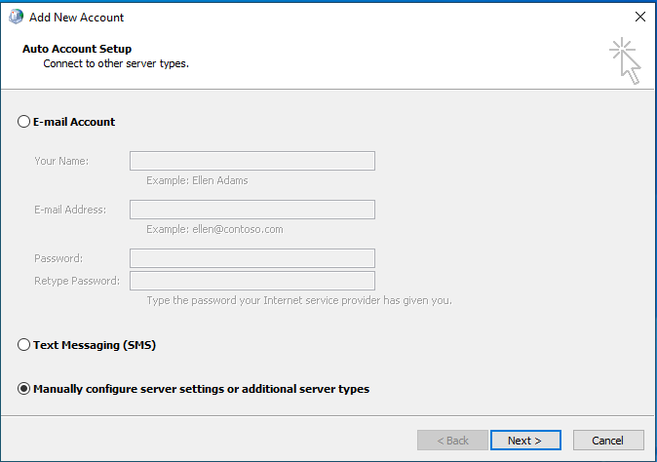

1. Select “ Internet E-mail (to connect to POP or IMAP server )” and click on “Next” button.

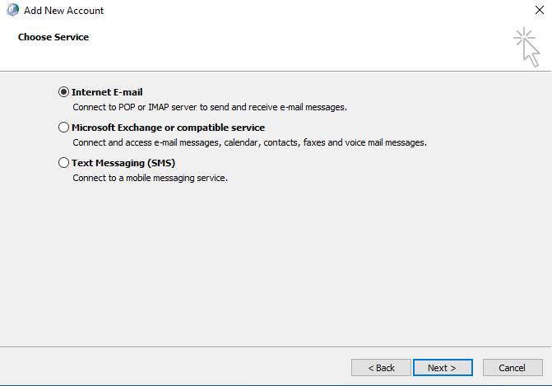

1. Fill user and server information as shown below and click on “More Setting”.

Incoming Server for External Network –qasid.iitk.ac.in

Outgoing Server for External Network- mmtp.iitk.ac.in

Incoming Server for Internal Network- newmailhost.cc.iitk.ac.in

Outgoing Server for Internal Network- smtp.cc.iitk.ac.in

And port no Incoming server is – SSL\TLS 993

Port no Outgoing Server is –SSL\TSL 465

**Note: use “External Network” setting for Laptops/Mobiles/ tablets and “Internal Network” setting only for Desktop.**

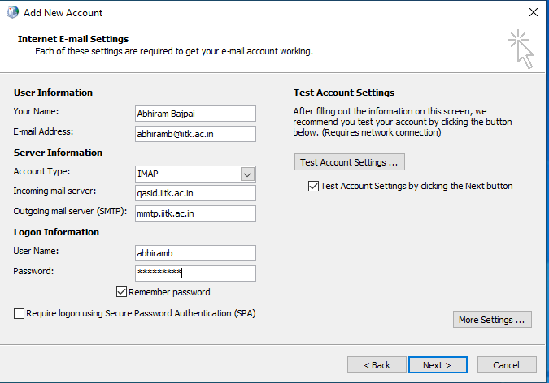

1. Select “Outgoing Server” tab and Enable “My outgoing server SMTP required authentication.

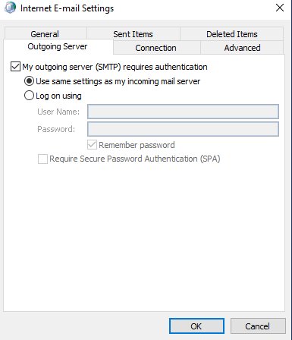

1. Select “Advance” tab and update the information as shown as below.

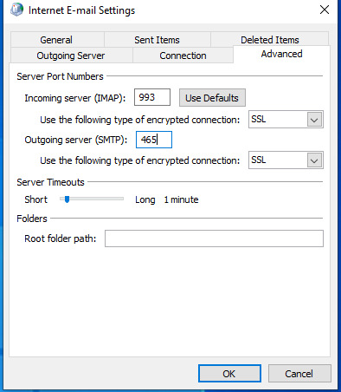

1. Click “Close” after Successfully Configuration.

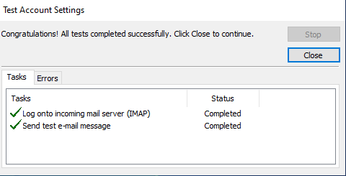

1. Account successfully added and Click on “Finish” Button.

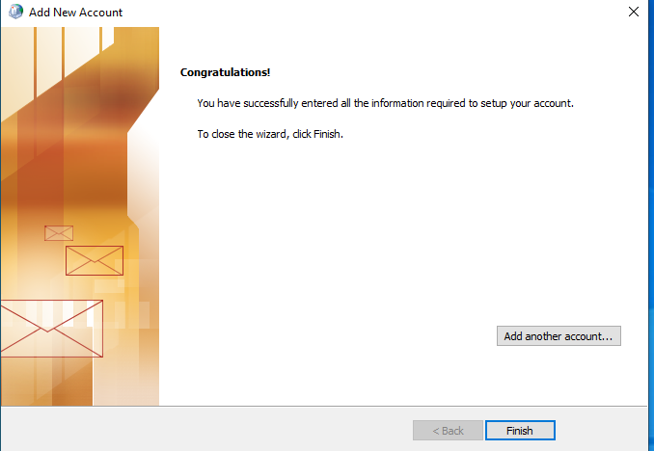

1. Preview for Configure Outlook as below.

